From: https://rwmalonemdllc.com/mrna-vaccine-inventor as of January 2022.

The True Story of How mRNA Vaccination was Invented
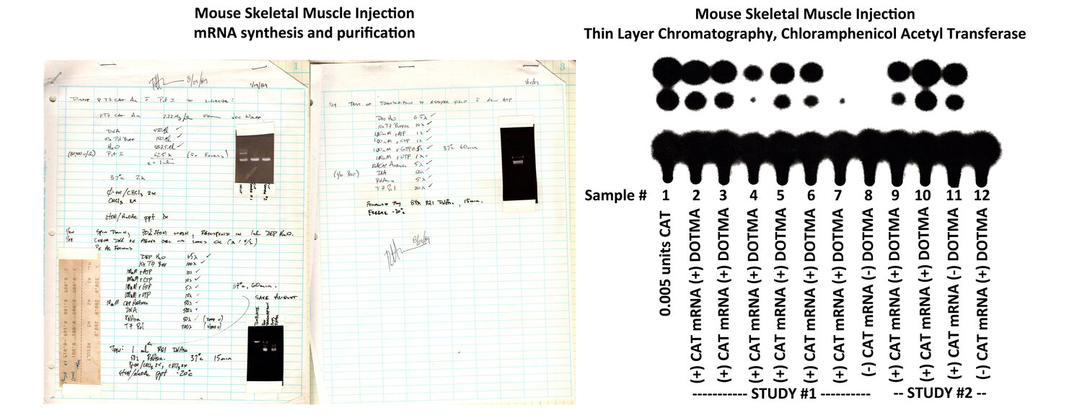

IT ALL STARTED WHEN…
Dr. Malone is the inventor of mRNA vaccines (and DNA vaccines). He also discovered lipid mediated and naked RNA transfection technologies.
It all started when he was at the Salk Institute in 1987 and 1988. There, he pioneered in-vitro RNA transfection and also in-vivo RNA transfection (in frog embryos, as well as mice).
This resulted in his seminal paper: Cationic liposome-mediated RNA transfection RW Malone, PL Felgner, IM Verma. Proceedings of the National Academy of Sciences (PNAS) 86 (16), 6077-6081
His filed patent and disclosures from the Salk included in-vivo RNA transfection and also methods for mRNA stabilization - now being claimed as invented by others. These are available for review.
His research was continued at Vical in 1989, where the first in-vivo mammalian rat experiments were designed by him. The mRNA, constructs, reagents were developed at the Salk institute and at Vical by Dr. Malone, this included dosing amounts for the in-vivo experiments. RNA and DNA were sent to Dr. Jon Wolff via Fedex. Dr.Wolff at the University of Wisconsin injected mice and rats. The initial patent disclosures for RNA and DNA vaccination were written by Dr. Malone in 1988-1989. Dr. Malone was also an inventor of DNA vaccines in 1988 and 1989.
This body of work resulted in over 10 patents and numerous publications, yielding about 7000 citations for this work. The paper was the first showing data for DNA and RNA side by side for in-vivo (the first paper for in-vivo DNA):
Direct gene transfer into mouse muscle in vivo. Wolff JA, Malone RW, et al. Science. 1990;247(4949 Pt 1):1465-8. Cited in 4,750 articles, is the result of that work.
In 1989, research was performed that gave rise to the 10+ groundbreaking patents on mRNA vaccination, all with a priority date of March 3, 1989. This is the same priority date as the Salk Patent application, showing that the two institutions were working together (without Robert’s knowledge). These patents are the first published research on mRNA vaccination. The titles and links to the patents are listed in the documents below. These patents have proof of principle experiments on mRNA vaccines - that clearly document that the invention worked and that these are the first experiments showing this.
Vical was to license the Salk Technology. Instead, they hired Robert’s thesis advisor from the Salk and soon after, the Salk dropped the patent and Vical never pursued a license from the Salk. Due to an employee contract with Vical, this stopped Robert from working in the field commercially for a decade. Vical claimed all the Salk research happened at Vical and sent a cease and desist letter.
Dr. Malone carried on his research into mRNA vaccination during the 1990s, culminating in a mucosal patent that was issued in 2000. He also helped revolutionized the field of cationic liposomes for the use in RNA vaccinations. This work was so far ahead of its time, that only now is the world turning to mucosal mRNA vaccination as a method of immunization. For a listing of some of his work, see the publications at the end of this page.
Scientifically trained at UC Davis, UC San Diego, and at the Salk Institute Molecular Biology and Virology laboratories, Dr. Malone received his medical training at Northwestern University (MD) and Harvard University Medical School (Clinical Research Post Graduate) , and in Pathology at UC Davis, He has almost 100 peer-reviewed publications, and has been an invited speaker at about 50 conferences.

For the full backstory on the discovery of mRNA vaccination, as written by Dr. Malone’s partner and wife, please download the PDF below:
A SCIENTIFIC EDUCATION: THE EARLY DISCOVERIES OF RNA VACCINATION


Image from Heidi News
From an article on Dr. Malone’s discoveries,

Intellectual Rape at the Salk Institute
“Robert Malone was 29 when he made a major discovery: It is possible to bring messenger RNA protected by a fat ball into cultured cells to produce proteins. The very principle of RNA vaccines. He was then at the Salk Institute, the temple of genetic research. Amazing results, which will be repeated on frog embryos. But skepticism around RNA and a never-filed patent will crush his hopes and waste years. Robert Malone today has the bitterness of those who were right too early…”

mRNA Vaccine and RNA Transfection/Delivery Papers and Patents directly derived from Robert W Malone’s research
A novel approach to study packaging of retroviral RNA by RNA transfection (Abstract). RW Malone, P. Felgner, I. Verma. RNA Tumor Viruses, May 17-18, 1988. Cold Spring Harbor
mRNA Transfection of cultured eukaryotic cells and embryos using cationic liposomes. Malone RW. Focus. 1989; 11:61-8
The Vical patent that was filed with the USPTO on 3/21/1989. Note that the cover letter hides this - and says it was filed on 3/29/89.
THE VERY FIRST mRNA VACCINE EXPERIMENTAL DATA 1990 (from Vical to patent office)
DNA and RNA Transfection and Vaccination (Abstract). First Place, Northwestern AOA Research Symposium Competition for Medical Students: 1989.
Cationic liposome-mediated RNA transfection. Malone RW, Felgner PL, Verma IM. Proc Natl Acad Sci (PNAS) U S A. 1989;86(16):6077-81. Cited in 749 articles.
Direct gene transfer into mouse muscle in vivo. Wolff JA, Malone RW, et al. Science. 1990;247(4949 Pt 1):1465-8. Cited in 4,750 articles. Note that Robert was a student at Northwestern, and was never affiliated with University of Wisc.
High levels of messenger RNA expression following cationic liposome mediated transfection tissue culture cells. Malone R, Kumar R, Felgner P. NIH Conference: “Self-Cleaving RNA as an Anti-HIV Agent (abstract). Washington, DC June 1989.
Cationic liposome-mediated RNA transfection. Dwarki VJ, Malone RW, Verma IM. Methods Enzymol. 1993;217:644-54. Cited in: 102 articles.
Delivery of exogenous DNA (includes mRNA) sequences in a mammal P Felgner, JA Wolff, GH Rhodes, R Malone, D Carson. Biotechnology Advances 1993: 15 (3-4), 763-763
Lipid-mediated polynucleotide administration to deliver a biologically active peptide and to induce a cellular immune response (includes mRNA). P Felgner, JA Wolff, GH Rhodes, R Malone, D Carson. Assigned to Vical, Inc and licensed to Merck. No. 7,250,404, date of issue: 7/31/07 Cited in 105 articles. Priority Date: 3/21/1989.
Lipid-mediated polynucleotide administration to reduce likelihood of subject's becoming infected (includes mRNA). P Felgner, JA Wolff, GH Rhodes, Robert W Malone, D Carson. Assigned to Vical, Inc and licensed to Merck. US Pat. Ser. No. 6,867,195 B1. Date of issue: 3/15/05. Priority Date: 3/21/1989.

mRNA vaccination experiment found in mRNA vaccine patents, with a priority date of 1989. This example comes from patent #6,867,195.
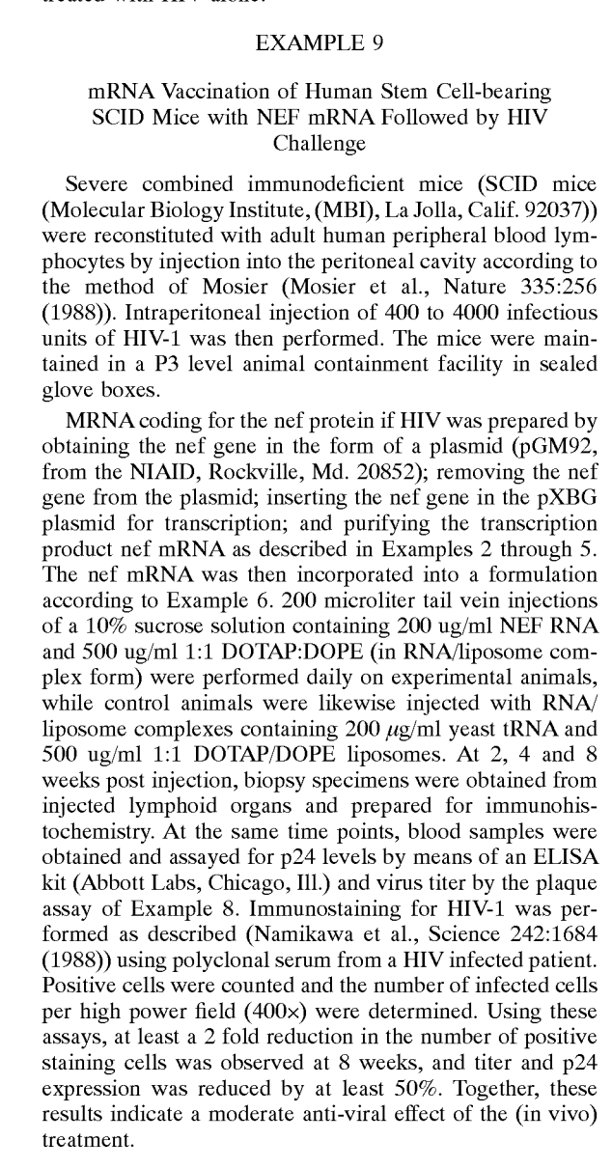

Generation of an immune response to a pathogen (includes mRNA). P Felgner, JA Wolff, GH Rhodes, Robert W Malone, D Carson. Assigned to Vical, Inc and licensed to Merck. US Pat. Ser. No. 6,710,035. Date of issue: 3/23/04. Citations: 39 articles. Priority Date: 3/21/1989.
Expression of exogenous polynucleotide sequences in a vertebrate, mammal, fish, bird or human (includes mRNA). P Felgner, JA Wolff, GH Rhodes, Robert W Malone, D Carson. Assigned to Vical, Inc, licensed to Merck. US Pat. Ser. No. 6,673,776. Date of issue: 1/6/04. Priority Date: 3/21/1989.
Methods of delivering a physiologically active polypeptide to a mammal (includes mRNA). P Felgner, JA Wolff, GH Rhodes, Robert W Malone, D Carson. Assigned to Vical, Inc, licensed to Merck. US Pat. Ser. No. 6,413,942. Date of issue: 7/2/02. (cited in 150 articles). Priority Date: 3/21/1989.
Induction of a protective immune response in a mammal by injecting a DNA sequence (includes mRNA). P Felgner, JA Wolff, GH Rhodes, Robert W Malone, D Carson. Assigned to Vical, licensed to Merck. US Pat. Ser. No. 6,214,804, date of issue: 4/10/01. Cited in 360 articles. Priority Date: 3/21/1989.
DNA vaccines for eliciting a mucosal immune response (includes mRNA). US Pat. Ser. No. 6,110,898. Inventors: RW Malone and Jill Glasspool Malone. Date of issue: 8/29/00. Cited in 40 articles. Priority Date: 1996.
Induction of a protective immune response in a mammal by injecting a DNA sequence (includes mRNA). P Felgner, JA Wolff, GH Rhodes, Robert W Malone, D Carson. Assigned to Vical, Inc, licensed to Merck. US Pat. Ser. No. 5,589,466. Date of issue: 12/31/96. Cited in 899 articles. Priority Date: 3/21/1989.
Delivery of exogenous DNA sequences in a mammal (includes mRNA). Assigned to Vical, Inc, licensed to Merck. P Felgner, JA Wolff, GH Rhodes, Robert W Malone, D Carson. US Pat. Ser. No. 5,580,859. Date of issue: 12/3/96. Cited in 1244 articles. Priority Date: 3/21/1989.
Generation of antibodies through lipid mediated DNA delivery (includes mRNA). P Felgner, JA Wolff, GH Rhodes, Robert W Malone, D Carson. Assigned to Vical, Inc, licensed to Merck. US Pat. Ser. No. 5,703,055. Date of issue: 12/30/97. Cited in 419 articles. Priority Date: 3/21/1989.
Formulations and methods for generating active cytofectin: polynucleotide transfection complexes. Robert W Malone, et al. US Pat. Ser. No. 5,925,623 7/20/99.
Cationic Transport Reagents. US Pat. Ser. No. 5,892,071 Robert W Malone, et. al. issued 4/06/99.
Polyfunctional cationic cytofectins, formulations and methods for generating active cytofectin: polynucleotide transfection complexes. Robert W Malone, et. al. US Pat. Ser. No. 5,824,812 issued 10/20/98.
Cationic Transport Reagents. Robert W Malone, et. al. US Pat. Ser. No. 5,744,625 issued 4/28/98.
Cationic Transport Reagents. Robert W Malone, et. al. US Pat. Ser. No. 5,527,928, date of issue: 6/18/96.
Marked enhancement of macaque respiratory tissue transfection by aurintricarboxylic acid. Glasspool-Malone J, …, Malone RW. Gene Med. 2002;4(3):323-2.
Enhancing direct in vivo transfection with nuclease inhibitors and pulsed electrical fields. Glasspool-Malone J, Malone RW. In Gene Therapy Methods: Methods Enzymol. 2002;346:72-91
Cutaneous transfection and immune responses to intradermal nucleic acid vaccination are significantly enhanced by in vivo electropermeabilization. Drabick JJ, Glasspool-Malone J, …, Malone RW. Mol Ther. 2001;3(2):249-55. Cited in 192 articles.
Theory and in vivo application of electroporative gene delivery. Somiari S, Glasspool-Malone J, … Malone RW. Mol Ther. 2000;2(3):178-87. Cited in 345 articles.
Efficient nonviral cutaneous transfection. Glasspool-Malone J, …, Malone RW. Mol Ther. 2000;2(2):140-6. Cited in 138 articles.
Developing dendritic cell polynucleotide vaccination for prostate cancer immunotherapy. Berlyn KA, …, Malone RW J Biotechnol. 1999;73(2-3):155-79
Models of Cationic Liposome Mediated Transfection. Gene Therapy and Molecular Biology. Ahearn A, Malone RW. Vol 4. Gene Therapy and Molecular Biology 1999;4
Cationic lipid-mediated gene delivery to murine lung: correlation of lipid hydration with in vivo transfection activity. Bennett MJ, …, Malone RW, Nantz MH. J Med Chem. 1997;40(25):4069-78
Considerations for the design of improved cationic amphiphile-based transfection reagents. Bennett MJ, …, Malone RW. Journal of Liposome Research 1996;6(3):545-65
Structural and functional analysis of cationic transfection lipids: the hydrophobic domain. Balasubramaniam RP, …, Malone RW. Gene Ther. 1996;3(2):163-72. cited in 172 articles.
A flexible approach to synthetic lipid ammonium salts for polynucleotide transfection. MJ Bennett, RW Malone, MH Nantz. Tetrahedron letters 36 (13), 2207-2210

